The Lobster Press 🦞
Standard Operating Procedure
━━━━━━━━━━━━━━━━━━━━━━━━━━━━━━━━━━━━━━━━━━━━━━━━━━━━━━━━━━━━
Rob Lobster Media Operations
for Lynch Family Businesses
🦞
March 31, 2026
rob.lobster.claw@gmail.com

TABLE OF CONTENTS
━━━━━━━━━━━━━━━━━━━━━━━━━━━━━━━━━━━━━━━━━━━━━━━━━━━━━━━━━━━━
Section 1: Overview
Section 2: Platforms
Section 3: Content Calendar — Weekly Posting Schedule
Section 4: Content Creation Workflow
Section 5: What Rob Needs from Joe and Staff
Section 6: Analytics and Metrics Tracking
Section 7: Brand Voice Guidelines
Section 8: Content Ideas Bank
Section 9: Posting Best Practices

SECTION 1: OVERVIEW
━━━━━━━━━━━━━━━━━━━━━━━━━━━━━━━━━━━━━━━━━━━━━━━━━━━━━━━━━━━━
Rob Lobster manages all social media content creation for the following Lynch Family Businesses:
- Tuckerton Lumber Company (TLC) — lumber, hardware, paint, Benjamin Moore
- Surfbox Portable Storage — portable storage units, approaching $1M revenue
- Keli Lynch Real Estate — realtor with offices in Ship Bottom + Crosswicks
- Keli Lynch Staging & Design — interior design and home staging
- Future: any additional Lynch family ventures

Content Tone
Humor-driven. Think Curb Your Enthusiasm, Seinfeld, Saturday Night Live.
NOT corporate. NOT boring. The kind of content people share, screenshot, and tag their friends in.

Click-bait taglines when done right. Never the same type of content twice — always unique, always fresh.

SECTION 2: PLATFORMS
━━━━━━━━━━━━━━━━━━━━━━━━━━━━━━━━━━━━━━━━━━━━━━━━━━━━━━━━━━━━

Phase 1 (Now)
- Facebook (all businesses)
- Instagram (all businesses)

Phase 2 (Future)
- TikTok
- Twitter/X
- Snapchat
- YouTube Shorts
- LinkedIn (for B2B lumber/construction content)

SECTION 3: CONTENT CALENDAR — WEEKLY POSTING SCHEDULE
━━━━━━━━━━━━━━━━━━━━━━━━━━━━━━━━━━━━━━━━━━━━━━━━━━━━━━━━━━━━
Day | Content Focus
Monday | TLC post — product tip, job site content, lumber industry humor
Tuesday | Surfbox post — storage hacks, moving humor, seasonal push
Wednesday | Keli Real Estate post — new listing, market data, open house
Thursday | TLC post — behind the scenes, employee spotlight, customer story
Friday | Keli Staging/Design post — before/after, design tips, staging humor
Saturday | Wild card — best raw content from the week, any business
Sunday | Rest or engagement day — respond to comments, share customer posts

Goal: Minimum 5 posts per week across all platforms. Ramp to 7+ as we build momentum.

SECTION 4: CONTENT CREATION WORKFLOW
━━━━━━━━━━━━━━━━━━━━━━━━━━━━━━━━━━━━━━━━━━━━━━━━━━━━━━━━━━━━
Step 1 — RAW CONTENT SUBMISSION
Joe or staff sends raw content (photos, videos, voice memos, ideas) to:
rob.lobster.claw@gmail.com

Email subject line format:
PRESS / [Company] / [brief description]

Examples:
- PRESS / TLC / raccoon caught in lumber yard
- PRESS / Surfbox / customer loading unit at the beach
- PRESS / Keli RE / new listing 381 West 12th Ship Bottom
- PRESS / Keli Staging / before and after kitchen reno
- PRESS / TLC / funny customer interaction

What to include in the email:
- Photos and/or video (attached or links)
- Brief description of what happened / context
- Any specific message Joe wants to convey
- Who is in the content (for tagging/permissions)
- Any deadline (e.g., "post before weekend")

Step 2 — ROB CREATES 3 CONCEPTS
Rob reviews raw content and emails back 3 creative concepts within 24 hours.
Email subject line format:
CONCEPT / [Platform(s)] / [2-Word Summary] / [Company]

Examples:
- CONCEPT / Instagram+Facebook / Raccoon Release / Tuckerton Lumber
- CONCEPT / Facebook / Beach Storage / Surfbox
- CONCEPT / Instagram / Kitchen Glow-Up / Keli Staging

Email body includes:
- Thumbnail of raw content
- CONCEPT 1: Title, tagline, style description, recommended platform
- CONCEPT 2: Title, tagline, style description, recommended platform
- CONCEPT 3: Title, tagline, style description, recommended platform
- ROB'S RECOMMENDATION: which concept and why
- Estimated completion time

Step 3 — JOE REVIEWS AND DIRECTS
Joe replies with one of these shorthand commands:
"Go 1" | Build concept 1
"Go 2" | Build concept 2
"Go 3" | Build concept 3
"Go 2 but change tagline to..." | Build with modifications
"None — try again" | Rob creates 3 new concepts
"Go 1, post it" | Skip final review, post immediately
"Hold" | Save for later, don't build yet

Step 4 — ROB BUILDS THE POST
Rob creates the full post:
- Edits video/photo (cropping, text overlays, transitions, music)
- Writes caption with hashtags
- Formats for each platform (square for feed, 9:16 for reels/stories)
- Checks for errors, typos, brand consistency
- Adds company logo/watermark

Step 5 — FINAL APPROVAL
Rob emails completed post for review.
Email subject line format:
FINAL / [Platform(s)] / [2-Word Summary] / [Company]

Email body includes:
- Final image/video attached
- Caption text (copy-paste ready)
- Hashtags
- Recommended posting time
- Any platform-specific notes

Step 6 — POSTING
Joe replies "Approved" and Rob delivers the ready-to-post files + caption. Initially Joe or staff posts manually. Future: Rob may get direct posting access.

SECTION 5: WHAT ROB NEEDS FROM JOE AND STAFF
━━━━━━━━━━━━━━━━━━━━━━━━━━━━━━━━━━━━━━━━━━━━━━━━━━━━━━━━━━━━

From Joe (One-Time Setup)
- TLC logo (PNG, transparent background)
- Surfbox logo (PNG, transparent background)
- Keli Real Estate logo/branding
- Keli Staging logo/branding (if separate)
- Brand colors for each company (hex codes or "use what's on the website")
- Social media account handles for all platforms
- Login credentials for each social account (for future direct posting)
- Google Analytics access (for website traffic tracking)
- Any existing brand guidelines or style preferences

From Staff (Ongoing)
- Photos and videos from the lumber yard, job sites, deliveries
- Customer testimonials and reviews (screenshot or quote)
- New product arrivals at TLC
- Surfbox customer photos (with permission)
- Before/after staging photos from Keli
- New listings from Keli (address, photos, price, key features)
- Funny moments, behind-the-scenes clips, anything entertaining
- Employee milestones, birthdays, work anniversaries
- Community events TLC or Surfbox is involved in

Staff email format (same as Joe):
PRESS / [Company] / [brief description]
Send to: rob.lobster.claw@gmail.com

Who Should Be Sending Content
Person | Content Area
Paul Devaney (TLC Manager) | Yard operations, customer interactions
Joe Young (Manager) | Sales floor, deliveries
Edwin (Junior Manager) | Day-to-day yard moments
Neal and Denise (Outside Sales) | Job site photos, contractor projects
Keli Lynch | Listings, staging projects, open houses
Anyone with a phone | Anything funny or interesting at work

SECTION 6: ANALYTICS AND METRICS TRACKING
━━━━━━━━━━━━━━━━━━━━━━━━━━━━━━━━━━━━━━━━━━━━━━━━━━━━━━━━━━━━
Rob will track and report weekly on the following metrics:

Platform Metrics (Facebook + Instagram)
- Impressions (how many people saw the post)
- Reach (unique viewers)
- Engagement rate (likes + comments + shares / reach)
- Click-through rate (if link included)
- Follower growth (week over week)
- Best performing post of the week
- Worst performing post of the week
- Best time of day for engagement
- Top hashtags driving discovery

Google Analytics (Website Traffic)
- Total sessions from social media referrals
- Pages per session from social traffic
- Bounce rate from social traffic
- Top landing pages from social
- Conversion tracking (if applicable — contact forms, phone calls)
- Compare social traffic vs. organic search vs. direct

Advanced Metrics
- Share rate (how many people shared/reposted)
- Save rate (Instagram saves — indicates high-value content)
- Video completion rate (what % watched to the end)
- Story tap-through rate (Instagram stories)
- Comment sentiment (positive/negative/neutral)
- Competitor benchmarking (track 3-5 competitor accounts)

Monthly Report
Rob delivers a monthly Social Media Performance Report including:
- Total posts published by platform and business
- Top 3 performing posts with analysis of why they worked
- Bottom 3 performing posts with analysis of what to improve
- Follower growth trajectory
- Engagement trend (up/down/flat)
- Content type performance (video vs. photo vs. carousel vs. text)
- Recommendations for next month's content strategy
- Google Analytics social traffic summary

Tools Rob Will Use
- Meta Business Suite (Facebook + Instagram analytics)
- Google Analytics 4 (website traffic)
- Spotify for Business / Later / Buffer (scheduling, if approved)
- Canva or similar (graphic design for posts)
- FFmpeg (video editing)
- Platform native insights (Instagram Insights, Facebook Page Insights)

SECTION 7: BRAND VOICE GUIDELINES
━━━━━━━━━━━━━━━━━━━━━━━━━━━━━━━━━━━━━━━━━━━━━━━━━━━━━━━━━━━━

Tuckerton Lumber (TLC)
- Voice: Blue-collar humor, real people, no corporate BS
- Think: Mike Rowe meets Larry David at a lumber yard
Topics: Raccoon stories, customer shenanigans, product tips that are actually useful, "things you didn't know you needed," behind-the-scenes yard chaos
Hashtags: #TuckertonLumber #LBIBuilder #JerseyShoreContractor #LumberYardLife

Surfbox Portable Storage
- Voice: Helpful, fun, seasonal urgency
- Think: "You've got too much stuff and we've got the box"
Topics: Beach season prep, moving humor, storage hacks, declutter motivation, unit reveals
Hashtags: #SurfboxStorage #LBIStorage #BeachSeasonReady #PortableStorage

Keli Lynch Real Estate
- Voice: Warm, knowledgeable, local expert
- Think: Your friend who happens to be the best realtor on LBI
Topics: New listings, market updates, neighborhood spotlights, first-time buyer tips, "what this house looked like before Keli got her hands on it"
Hashtags: #LBIRealEstate #JerseyShoreHomes #ShipBottomNJ #BeachHouseLife

Keli Lynch Staging & Design
- Voice: Design-forward, before/after dramatic reveals
- Think: HGTV energy without the fake drama
Topics: Staging transformations, design tips, color trends, "staging secrets that sell homes faster"
Hashtags: #HomeStaging #StagingToSell #InteriorDesign #BeforeAndAfter

SECTION 8: CONTENT IDEAS BANK (Rotating)
━━━━━━━━━━━━━━━━━━━━━━━━━━━━━━━━━━━━━━━━━━━━━━━━━━━━━━━━━━━━

TLC Content Ideas
- "Things contractors say" (series)
- Employee of the month spotlight
- "What's this tool?" quiz posts
- Seasonal project ideas (deck season, fence season, etc.)
- Benjamin Moore color of the month
- Customer project showcases
- "Lumber yard confessions" (funny series)
- Price comparison: big box vs. TLC (value proposition)
- "Ask the expert" Q&A posts
- Behind the forklift (day in the life)

Surfbox Content Ideas
- "What fits in a Surfbox" challenge
- Seasonal storage tips countdown
- Customer unboxing/loading videos
- "Declutter your life" motivational posts
- Beach house renovation storage solutions
- Moving day fails (humor)
- Unit of the week showcase

Keli RE / Staging Content Ideas
- Just listed / just sold celebrations
- "Guess the listing price" interactive posts
- Room transformation reels (before/after)
- Local restaurant/business spotlights (community building)
- "What $X gets you on LBI" comparison posts
- Staging secrets series
- Open house recaps
- Market minute (quick weekly stats)

SECTION 9: POSTING BEST PRACTICES
━━━━━━━━━━━━━━━━━━━━━━━━━━━━━━━━━━━━━━━━━━━━━━━━━━━━━━━━━━━━
- First 3 seconds of any video must HOOK the viewer (text overlay, question, shocking visual)
- Captions should be front-loaded — put the hook in the first line
- Use 5-10 relevant hashtags (not 30 spam hashtags)
- Post at peak times: 9-11 AM and 6-8 PM local time
- Respond to every comment within 24 hours
- Cross-post between Facebook and Instagram (but customize format)
- Video outperforms photo. Photo outperforms text. Always.
- User-generated content (customer posts/reviews) builds trust
- Never post the same content twice — always remix, always fresh
- When in doubt, make it funny

━━━━━━━━━━━━━━━━━━━━━━━━━━━━━━━━━━━━━━━━━━━━━━━━━━━━━━━━━━━━
Rob Lobster Media Operations
Managed by Rob Lobster 🦞 for the Lynch Family Businesses
Version 1.0 — March 31, 2026

Visual Overview Chart
The Lobster Press — 5-step content factory workflow for Lynch Family Businesses.
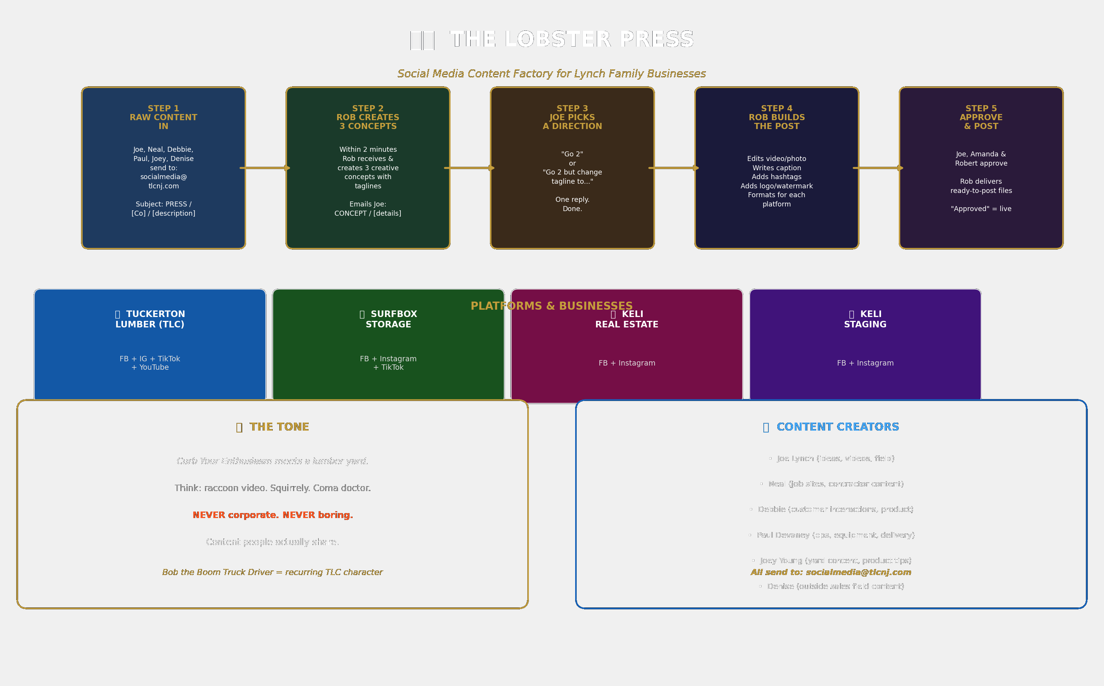

The Lobster Press — Visual Overview (Print Version)

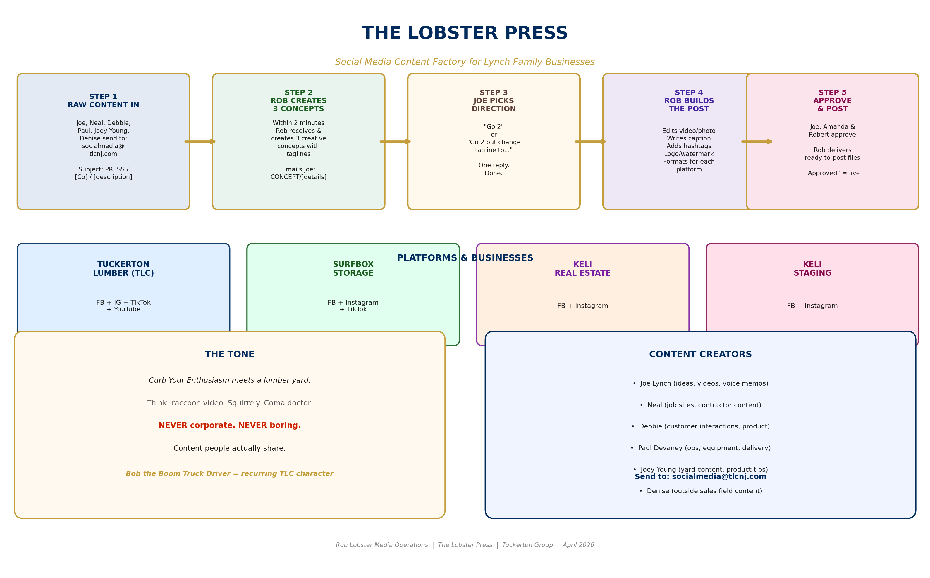
The Lobster Press — Social Media Content Factory Flow Chart

The Lobster Press — Visual Overview (Print Version)
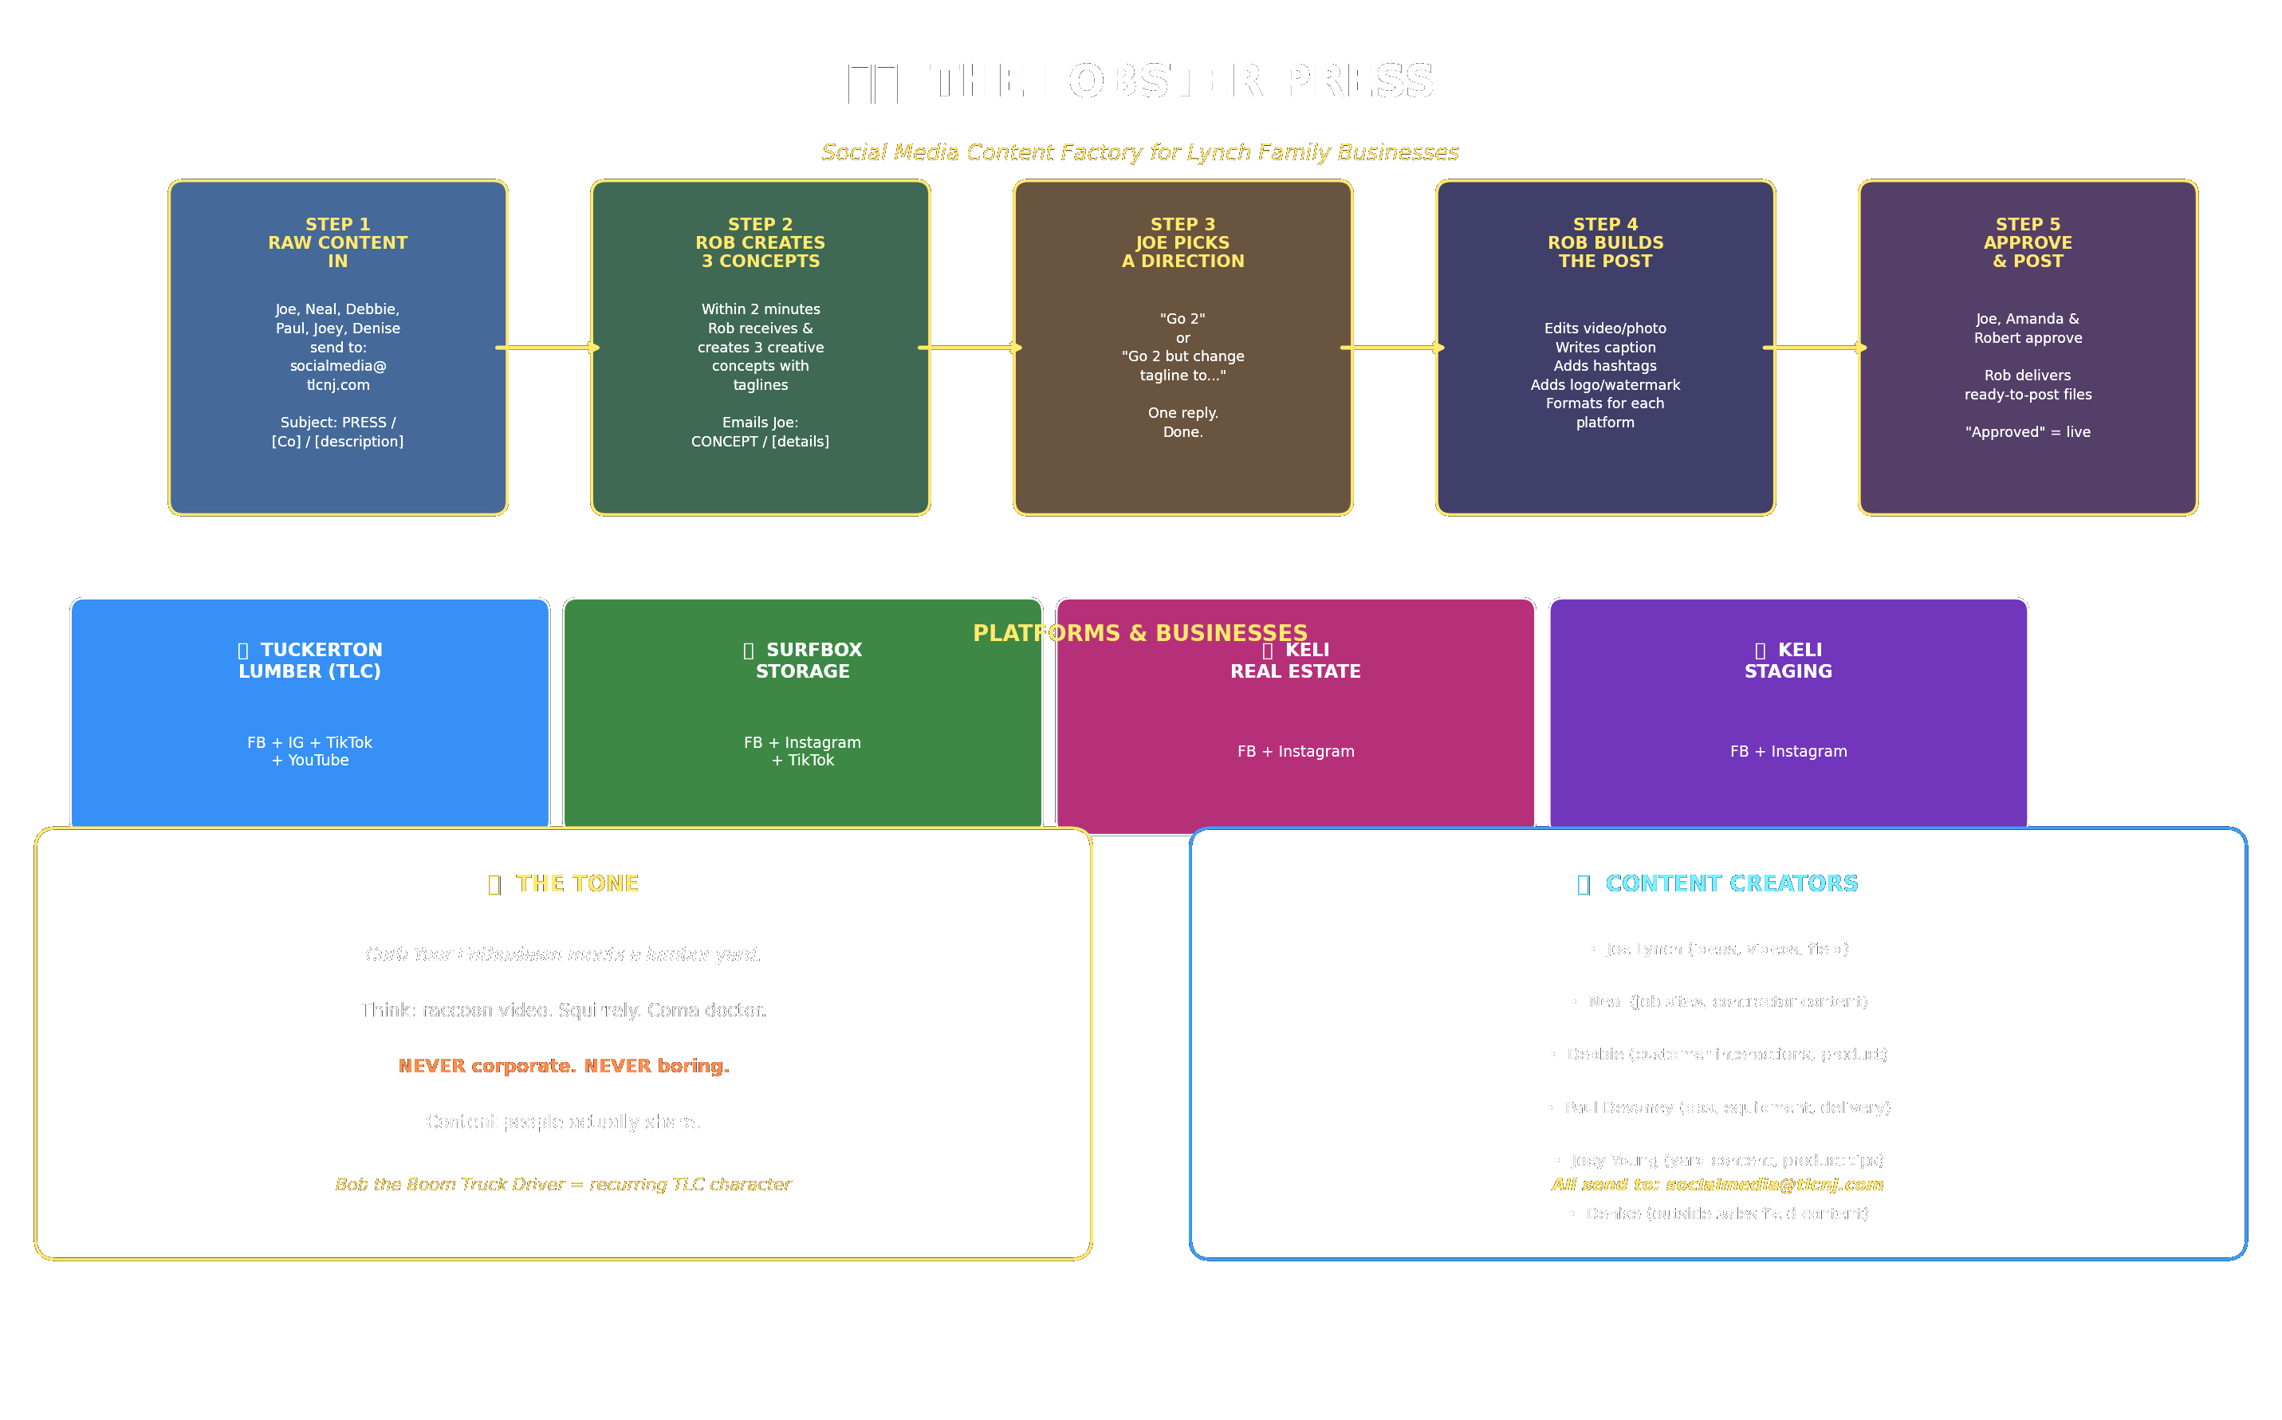
Light background — print-friendly version. Added per Joe ROB ACTION, April 7, 2026.

The Lobster Press — Visual Overview (Print Version)

The Lobster Press — Visual Overview (Print Version)
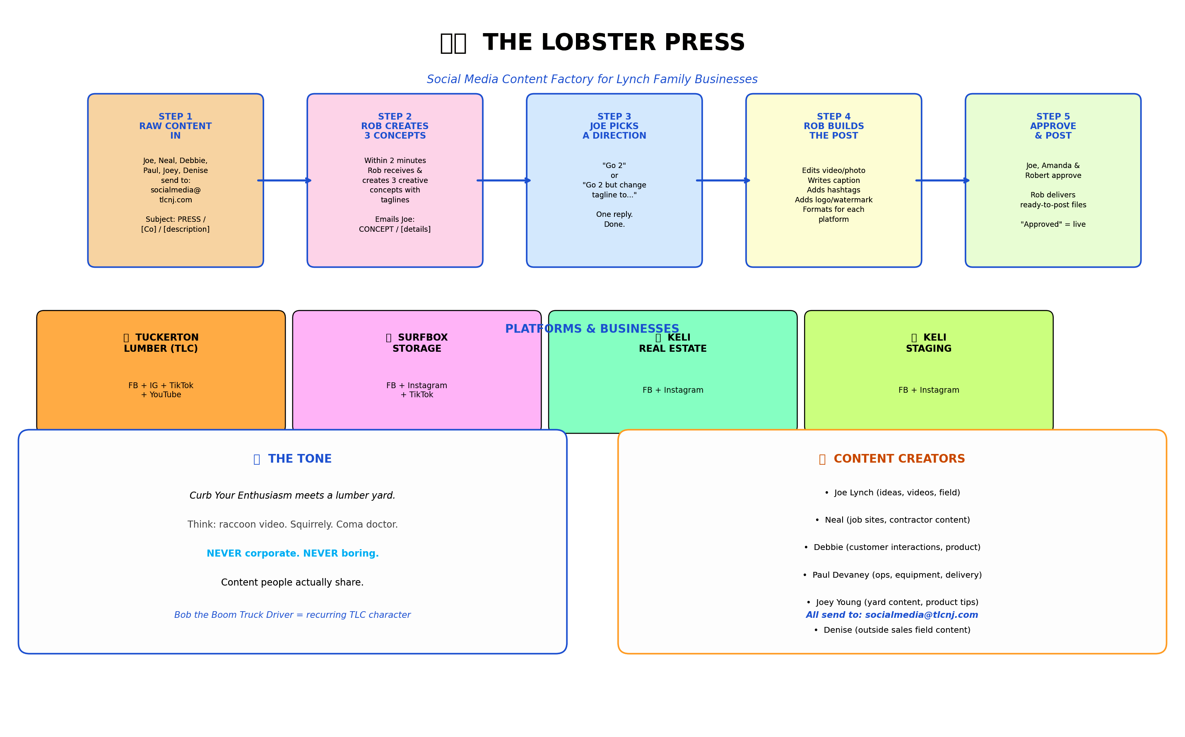
Light background version — print-friendly. Added per ROB ACTION, April 8, 2026.

