TUCKERTON GROUP
2026 Strategic Goals & Status Tracker
Tuckerton Lumber Company | Surf City | Surfbox Portable Storage
Paul Devaney | Joe Young | Edwin | Last Updated: April 7, 2026
Below is our working copy of the 2026 goals we’ve set for the Tuckerton Group and what we are doing to meet them. Each week we will meet as a team and report on where we stand and the status of every project listed below. After each meeting, I will dictate the updates and produce a fresh summary so this document always reflects our most current goals, action items, and progress. Think of this as our living playbook — it grows and changes as we execute.

APRIL 7, 2026 — MANAGEMENT MEETING NOTES
Paul Devaney and Joe Young came into the office and reviewed all open items. Notes below capture updates across all sections from this meeting.

SECTION 1 — CASH FLOW & INVENTORY MANAGEMENT
- Ethan and Joey are on board with the incentive plan.
- Ethan's staff salaries increased; year-end bonuses for staff increased.
- Ethan's own year-end bonus increased.
- Joey sent email and copied Judy in accounting — compensation package handled.
- Edwin will work side-by-side with Ethan to run Min/Max and coordinate store operations.
- Monthly Metrics: Joey is working on a 6-month paint inventory tracking report covering Benjamin Moore and Lancaster performance.
- Ethan has an incentive package tied to hitting inventory reduction targets. Joey has the numbers and the package details.

SECTION 2 — PRICING & MARGIN IMPROVEMENT
- Baseball season is underway — "we are in the 3rd inning."
- Open Question: When will new prices be reflected on shelves? A 10–15% price increase is needed across key categories.
- Paul is working on a delivery price hike — implementing a formal delivery charge at Tuckerton.
- Paige to begin tracking: minimum $15 delivery charge, invoiced as a SEPARATE LINE ITEM for all customers. Even if the charge is waived, it must appear on the invoice.
- PARKING POLICY: All employees must park at the 539 Paint Store parking lot — NOT in customer spots at any location.

SECTION 3 — STAFFING & OVERHEAD REDUCTION
- Joe directed Judy to start holding people accountable. ADP overtime report to be sent to Paul Devaney, Joe Lynch, and Joe Young on a regular basis.

SECTION 4 — SALES GROWTH & MARKETING
- Neal should be sending weekly call notes/reports — even if brief.
- Follow-up needed: Did Neal work the Keller Daughter account? How did the north side sales trip go?
- Neal should start sending all social media content to The Lobster Press Outlook inbox: socialmedia@tlcnj.com.
- Follow-up: Is Neal using the "Sawfish" as a door opener?

SECTION 5 — TECHNOLOGY & SYSTEMS
- Follow-up needed: Did Edwin call Epicor? Status unknown — requires confirmation.

SECTION 6 — CAPITAL, EQUIPMENT & NEW OPPORTUNITIES
- Atlantic City Equipment Show: We missed it. Research when the NEXT show is — we need forklifts. Follow up.
- Billboard Rental: Paul is working on securing the billboard. Follow-up needed.
- Grow Room at Surf City: 80% complete.
- 539 Paint Store — Marine Theme Concept: Continue brainstorming. Ideas discussed include: upholstery store, marine store, dock hardware, boat mechanics, boat storage, and jet ski store (Paul's idea). Paul is working on the Mexico concept and layout for the inside first floor.
- Bob (nephew of Lou from Host Riders): Expected to call this week — upholstery and detailing person in Tuckerton. Joe's contact will provide the phone number.
- Joe V: Has his own power washing and boat painting business and works for Tuckerton Borough. To be contacted.
- California Closets: Paul and Geo prepared the room; Joey confirmed the numbers. Launch date: May 1.
- Heat for 539 Paint Store: Contacted Mike the plumber. He will be on-site this week to assess.
- Firehouse Surfbox Unit: Consider placing a firehouse-style unit at the store — 9' x 8' paint-can style unit.
- Waiting for Brandon from Mirage Wraps to wrap the new unit with Benjamin Moore design.
- Signage for Surf City Staircase: Brandon from Mirage Wraps needs to visit and set it up.
- Outdoor Furniture: Special orders may not work. Tabling for now. Lost Michelle accounts to Oscar Huber.
- New Cashier Counters: Ready to install this week.
- Project Homecoming / Household Goods Aisle: Davis Hand Store in Beach Haven temporarily closed — opportunity exists. Start journaling customer requests at both store registers. Edwin has already started at Surf City. Goal: stock what Dollar General carries (toaster ovens, etc.). Paul has a starter list. Schedule Keli and Renee to come in next week to help design the aisle.
- Tuckerton Lumber Pencils: Need to reorder. Jesse redesigned them — confirm new design before placing order.

SECTION 7 — REPORTING & ACCOUNTABILITY
- Edwin is creating a new weekly report that will be emailed out. Review the first edition when it arrives.
- Paul Mays noted as behind on calls — Joe Lynch and Joe Young are pulling ahead on activity.
- Paul found a possible new driver — to be vetted. Edwin could potentially train in Elizabeth City.
- Charleston, SC: Joe suggested it may be a great Surfbox location. (Joe noted with humor that Paul should tell him to shut up about it — duly noted.)

SECTION 8 — SOCIAL MEDIA / THE LOBSTER PRESS
The Lobster Press is now the official social media content factory for Tuckerton Lumber and Surfbox. All content creators (Joe, Neal, Debbie, Paul, Joey, Denise) send raw content to socialmedia@tlcnj.com with subject line: PRESS / [Company] / [description]. Rob Lobster processes content within 2 minutes, creates 3 concepts, Joe approves, and final posts go to Facebook, Instagram, TikTok, Twitter, and YouTube. Approval chain: Joe Lynch, Amanda, and Robert. See the Lobster Press SOP and overview chart (distributed separately) for full workflow details.

SECTION 9 — DRAINAGE / INFRASTRUCTURE
- Tuckerton Drainage Pond Update: John has the concrete box in the ground.
- Wants to add pipes from the railroad side of the property — NOT YET done.
- Has NOT yet run pipes to the wood side of the property.
- Joe to check on status in 2 days (by April 9, 2026).
- John blew up his machine — Joe is NOT paying for repairs. Noted.

─────────────────────────────────────────────────────────────────
2026 STRATEGIC GOALS — ORIGINAL WORKING COPY (March 17, 2026)

1. Cash Flow & Inventory Management
Owners: Joey Young & Edwin
Paint Department Inventory (Edwin)
- Joe to sit with Edwin before the Ethan meeting to walk through what we’re looking for on Min/Max settings in the paint department.
- Meeting scheduled with Ethan — Thursday next week at 1:00 PM. Agenda: review the 2025 commission calculation and tweak the 2026 structure so Ethan can set up a bonus program for his employees.
- After the initial meeting, bring Edwin and Ethan together that afternoon to get them synergized on lowering paint inventory.
All Other Product Lines (Edwin)
- Edwin to run Min/Max on all remaining product categories in-store to continue driving total inventory down.
- Use the current monthly inventory metrics that Joey runs to monitor Edwin’s progress on an ongoing basis.
- Set a specific dollar target for total inventory reduction and track monthly.
2. Pricing & Margin Improvement
Owners: Joey Young & Paul Devaney
Baseball Season Study (Joey)
- Joey’s report analyzed non-contractor sales from 2020 through 2025, March to August (“baseball season”). That seasonal window generated approximately $1.9 million in sales.
- Goal: increase profit by 10% on this segment, putting approximately $200,000 to the bottom line.
- The goal is not to set prices to a target margin. The goal is to find where we forgot to raise prices a year or two ago and the margin got eroded. Some of these items should be at 50–60% margin, not 40%.
- Joey is setting up a program to systematically raise prices as high as we can for the March–August residential window.
Lumber Desk & Special Orders (Paul)
- Paul to work with Jesse, Janna, and Ray at the lumber desk to get pricing up on lumber accounts and special orders.
- Paul to create a Special Order Gross Profit Parameter Sheet that each lumber desk clerk must follow. Minimum margin targets on special orders — if they need to go below, they get manager approval first.
Hardware Pricing
- We are underpriced on hangers, nuts, and bolts compared to Woodhaven and 84 Lumber. Room to raise prices on both contractors and residents.
3. Staffing & Overhead Reduction
Owners: Judy (with Joe’s oversight)
- Focus areas: store-use charges and overtime. Judy to analyze both and identify reduction targets.
- Joe will follow up directly with Judy to set expectations and timelines.
- Reduce summer part-time staffing hours below 2025 levels.
- Leverage the ADP recruitment program to cut advertising costs for new hires.
4. Sales Growth & Marketing
Owners: Paul Devaney & Joe
Outside Sales Team
- Paul to set up a conference call with Neil next Tuesday morning. Include Denise on the call.
- Paul believes there’s business on the north end of the island we’re missing.
- Paul to travel with Denise and Neil once a week to support prospecting efforts.
Promotional Campaigns
- Execute the nail campaign and hanger campaign promotions.
- Push list: focus on growing sales in targeted contractor product categories.
Store Presence
- Paul doing three days in Surf City, Edwin at least one or two days. Joey bounces back and forth so both stores are monitored at all times.
5. Credit Card Processing Fee Recovery
Owners: Amanda & Joe
- Joe to check whether Amanda has sent the email to Epicor reps regarding AI questions around APIs and their own tools, and when the credit card processing fee module is coming out.
- Goal: automatic surcharge applied at point of sale with zero manual intervention.
- Track monthly fee recovery dollars vs. total processing costs.
6. New Revenue Opportunities
Owners: Paul Devaney & Joey Young
California Closets
- Paul and Joey working with the California Closets reps. Hard numbers expected next week.
Blind Business
- Ask Paul what we can do to help grow the blind business. Set a specific growth target for 2026.
Tuckerton Paint Store
- Concentrate on the Tuckerton paint store as a priority revenue opportunity.
- Rent upstairs offices. Run an ad in the paper and on Facebook to attract a contractor tenant for the offices, then potentially the other part of the store.
- Marine store concept: Joey’s new vendor puts material on consignment. Eventually could market boats, detailing, and boat upholstery given proximity to the water.
- Heating installation needed. Joe Lynch to get Paul Mealy to bring in our plumber to assess the best approach. If we go with a full system, we really need to rent the upstairs to help pay for the cost.
Paint Can Display
- Paul building a 9 ft high x 8 ft wide paint can display. Use $18,000 in Benjamin Moore co-op money to pay for the wrap.
Outdoor Furniture
- Push outdoor furniture special orders. Create a brochure for the front of the Surf City store for customers to place special orders with vendors like Summer Classics and Outdoor Interiors (the old Michelle accounts). Paul to work this up.
New Cashier Counters
- New cashier counters to be installed within the next couple weeks.

7. Surfbox Portable Storage: Path to $1 Million
Owner: Paul Devaney
Social Media Marketing Campaign
- Launch social media marketing campaign to accelerate NJ market penetration.
- Hiring new employee Rob Lobster, available in the next couple weeks. He’ll use AI to create content and schedule it through our existing social media accounts.
- New SOP starting this week: each store creates one social media video per week. Content and format are open — just make one. Save to a Teams file on the server so we build a content library.
- Paul will use AI to generate ideas and work with Edwin to ensure each store produces content weekly.
- When the social media employee is up and running, we’ll have content to cut and splice for the spring/summer push.
- Target: Edwin, Paige, Joe, and Michael Galakis to have the social media employee fully operational by April 30.
Fleet Growth & Pricing
- Relocate the majority of NC boxes to NJ; maintain a satellite operation (~20 boxes and a truck) in North Carolina.
- Acquire additional units to grow the fleet — target 300+ boxes in NJ covering Cape May to Seaside Heights.
- Implement selective price increases on new rentals and renewals.
8. Tuckerton Site — Exterior Drain & Infrastructure
Owners: John Blum / Joe
- This week: John Blum picks up the concrete box from Atlantic Concrete.
- Next week: Install the concrete box.
- Week of April 2: Pipe installation. Target completion before Easter Sunday.
- Joe needs to order: three truckloads of clean 3/4-inch gravel for delivery next week.

2026 INITIATIVE ASSIGNMENTS
At-a-glance summary — Week of March 17, 2026
Initiative | Key Actions This Week | Owner(s)
Cash Flow & Inventory | Sit with Edwin on paint Min/Max; Ethan meeting Thurs @ 1:00; synergy session that afternoon | Joey, Edwin
Pricing & Margins | Baseball season pricing program setup; special order parameter sheet; hanger/bolt repricing | Joey, Paul
Staffing & Overhead | Joe follow up with Judy on store-use and overtime targets | Judy, Joe
Sales Growth | Neil/Denise conference call Tues AM; Paul travel with sales team; north island push | Paul, Joe
Credit Card Fees | Check Amanda’s Epicor email status re: API/AI/module | Amanda, Joe
New Revenue | California Closets numbers due; paint store ad for offices; paint can display; outdoor furniture brochure; new counters install | Paul, Joey
Surfbox to $1M | 1 video/store/week SOP starts; Rob Lobster onboarding; social employee target 4/30; fleet expansion | Paul
Site Infrastructure | John Blum picks up concrete box; Joe orders 3 loads gravel; pipe install week of 4/2 | John Blum, Joe

Next Meeting: _______________
Notes will be dictated at that meeting, and this document will be updated and redistributed.

The Lobster Press — Visual Overview
Content creation workflow for Lynch Family Businesses. See Rob Lobster for full SOP.
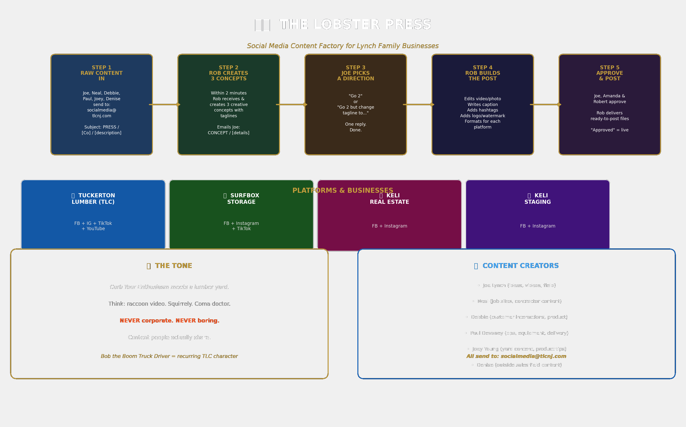

The Lobster Press — Visual Overview (Print Version)

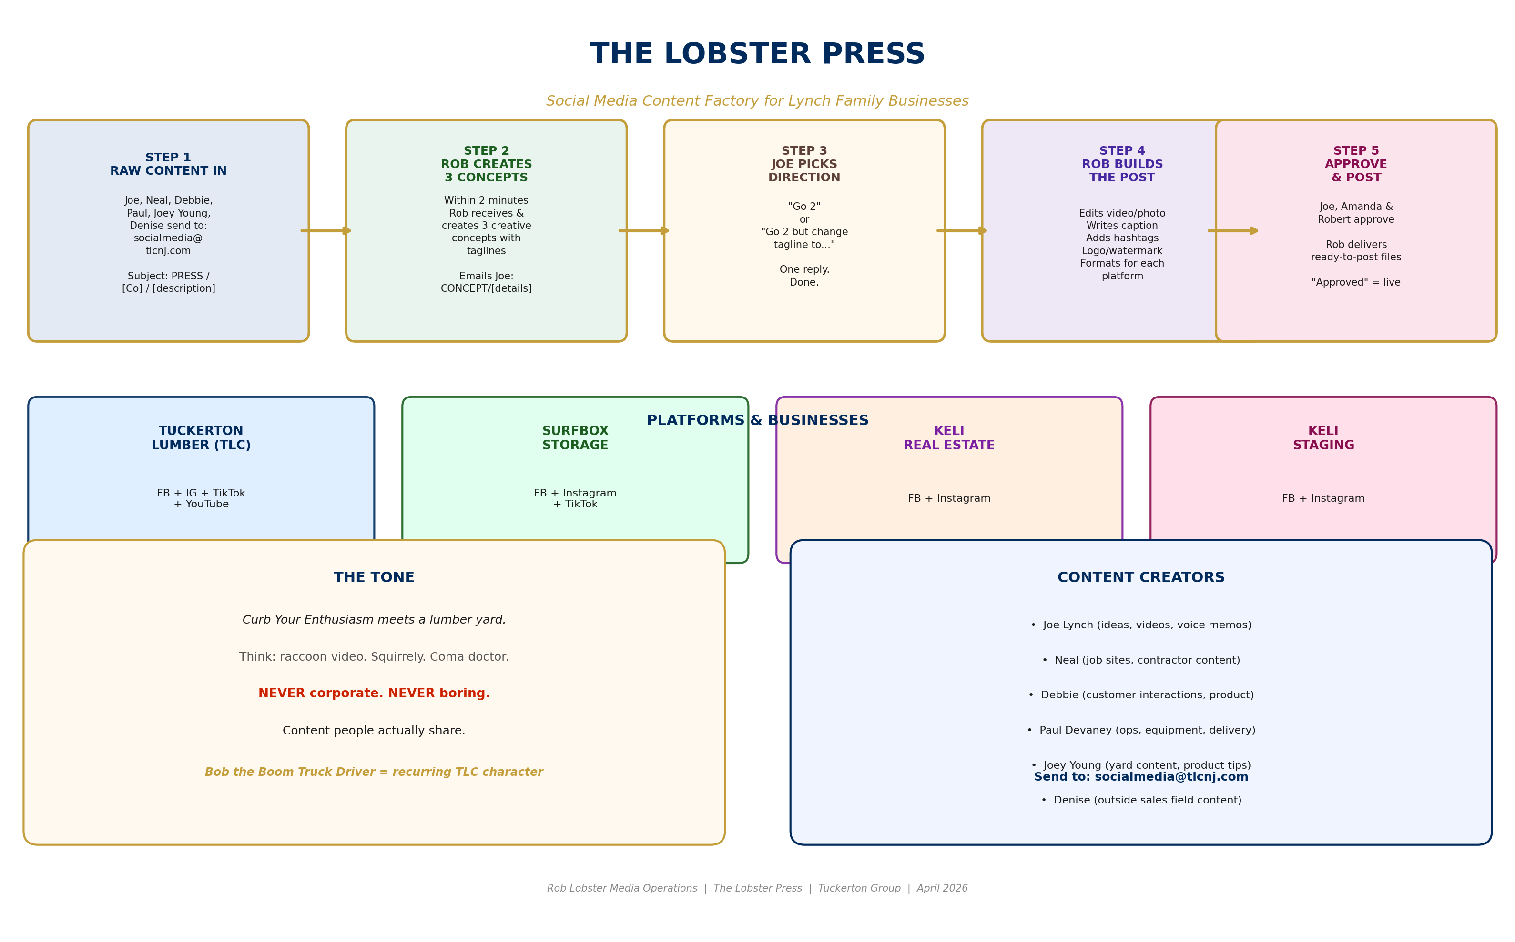
The Lobster Press — Social Media Content Factory Flow Chart

The Lobster Press — Visual Overview (Print Version)
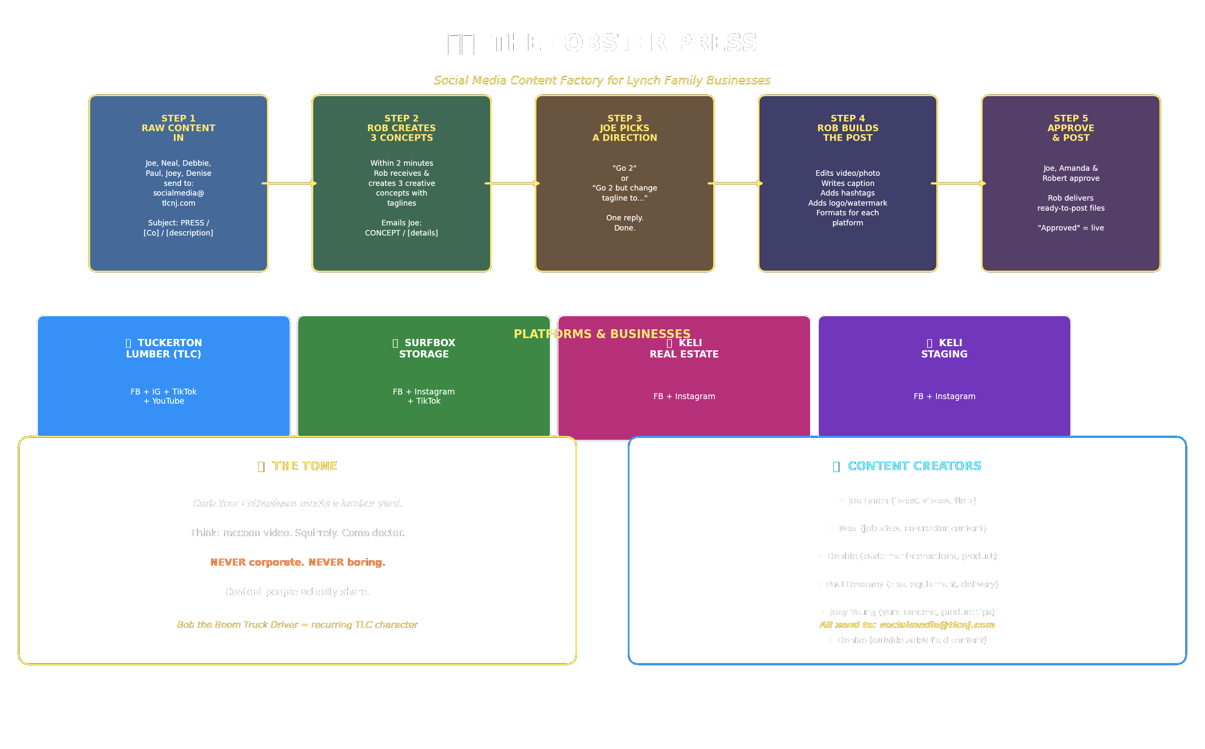
Light background — print-friendly version. See Rob Lobster for full SOP.
─────────────────────────────────────────────────────────────────

ACTION CARD — UPDATES (April 7, 2026)
✅ COMPLETED / DONE ITEMS
DONE: Switch back to Claude Max $200/mo plan
DONE: Reach out to Frank Capecci (neighbor, 12th St) — 973-229-9362
DONE: Neal/Denise — contractor prospect calls: Amon + Pagnotta
DONE: Haastrotters Boatyard — research status
DONE: Property tax appeal research — Chesterfield

📝 NEW NOTES / UPDATES
☐ Gio — $225 cash owed (driveway at parents' house)
↳ TEXT TOMMY TO SEE IF HE CUT CHECK
☐ Organize truck key rings — 5 rings: Firehouse, TD Banks, Truist, Surf City, Tuckerton
↳ WAITING ON LJ
☐ Brother Matt — property co-ownership / fair buyout discussion
↳ WARN MATT FUNDS WILL BE NEEDED

The Lobster Press — Visual Overview (Print Version)

The Lobster Press — Visual Overview (Print Version)
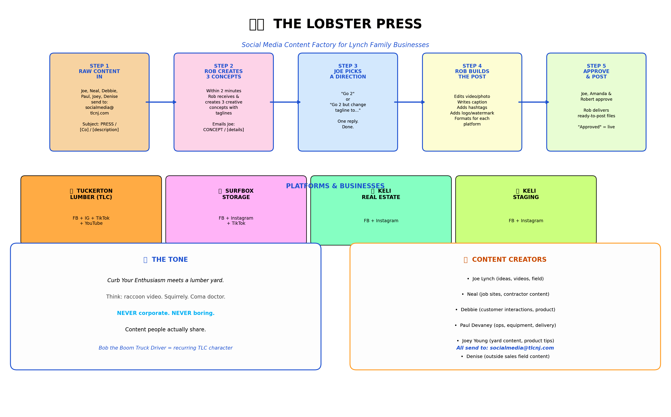
Light background version — print-friendly. Added per ROB ACTION, April 8, 2026.

